

**Dept of Information Technology**

**Edusphere(Online Learning Experience)**

**Guide: Mr.K.Shareef** AssociateProfessor

**Batch No:02**

**Team Members :**

**22R21A12J8 : T.Jyothi**

**22R21A12D0 : A.Maanasa**

**22R21A12D1 : A.Jaya**

**22R21A12G8 : M.Sruthi Laya**

**22R21A12E4 :B.Sneha Reddy**

# INTRODUCTION

* Edusphere revolutionizes education with real-time access, empowering learners to engage seamlessly with educational resources. It fosters collaborative learning through live discussions and virtual classrooms, while enabling educators to adapt teaching methods dynamically. Edusphere prioritizes security, privacy, and reliability, shaping a future of accessible, high-quality education worldwide.
* Edusphere is changing how we learn by letting us access lessons instantly and work together with teachers and classmates. It adapts to how each person learns best and always works well, making education better for everyone, everywhere.

**ABSTRACT**

To address this challenge, idea of ‘Edusphere’ is proposed. At first we create a user friendly interface which is necessary for login and authentication. After login, dashboard shows the course list which we currently accessing. For a friendly course interaction adaptive learning algorithms are used. Firstly, user takes an initial assessment of their respective course. Based on the performance results are analysed. User can revise concepts using cheat-sheets, formulae list, interactive quizzes, Through the results, the system presents questions on user’s familiar topics and feedback is provided. However existing solutions are working to provide an interactive learning experience to its users. To achieve this, the technologies used are Java(backend), node.js (user interface), javascript for website functionalities.

# OBJECTIVES

* Edusphere faces challenges ensuring everyone can access lessons instantly despite slow internet. Keeping data safe while letting students interact is hard. Adapting to different learning styles and tech setups while staying reliable is a big task. But solving these problems will make learning better for all.
* Ensuring data security while making sure everyone can easily access lessons, and

keeping everything working smoothly with different tech setups.

# EXISTING SYSTEM

* In the existing system there are numerous educational platforms and management systems these platforms include Moodle, canvas, google classroom, LMS.
* Existing systems could lack personalized learning experiences, may require substantial training for users, and might not integrate seamlessly with existing educational workflows.

# PROPOSED SYSTEM

* + - Our proposed system offers robustness and security, leveraging its vast libraries and frameworks for reliable data handling and protection against vulnerabilities.
    - Our project ensures real time updates and responsiveness with its asynchronous, event driven architecture, enhancing user experience.
    - It boosts website interactivity, enabling, dynamic content rendering and client-side scripting for smoother user interactions and improved engagement with the platform.
    - Good user Interface(UI) gives user a better interacting experience.
    - Due to JDBC, information retrieval will be easy.

# SYSTEM REQUIREMENTS

**Hardware Requirements:**

* + Processor: Intel Core i5 or equivalent
  + RAM: 8GB or higher
  + Hard Disk: 500 GB SSD

**Software Requirements:**

* Operating System: Windows 10 or later
* Programming Language: Java(Backend), Node.js, HTML, CSS, Javascript

# MODULES

* + - Admin Module
    - UserModule

**Admin Module:**

User and content management: Admins oversee user accounts, roles, permissions, and educational content, ensuring organization and accessibility

**User Module:**

Under User Module, there are two types of users.

1.Faculty

2.Student

Accessing educational content: Users can browse, search, and access lectures, assignments, and other learning materials, submit assignments.

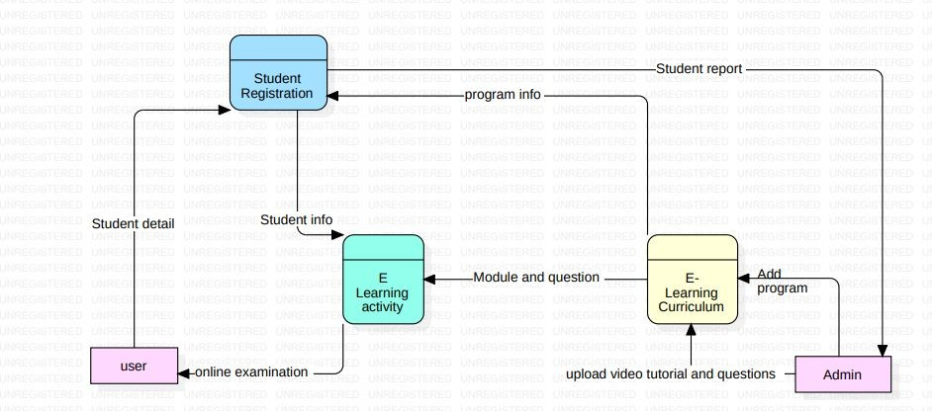 DFD FOR ADMIN MODULE

DFD FOR STUDENT MODULE

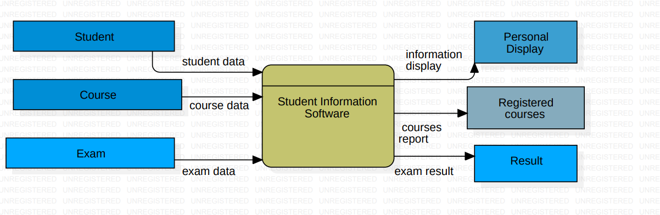

DFD FOR FACULTY MODULE

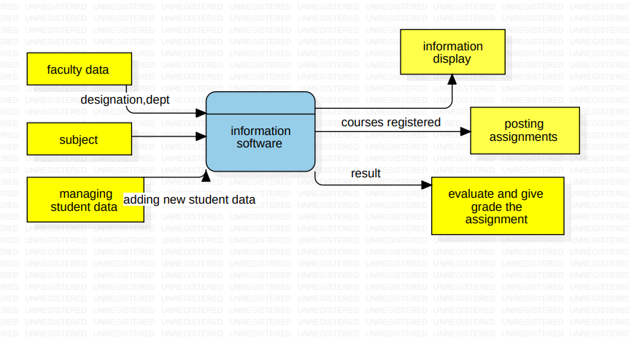

CONCLUSION

* It can have a positive impact on learners and educators.
* Users can get a better learning experience based on good User Interface.
* Based on feedback personalized course path is suggested and implemented.
* Therefore, ‘Edusphere’ can engage users in an effective manner and provide a better user experience.
* Through it’s interactive learning methods, it takes the positive response from users

REFERENCES

* [www.google.com](http://www.google.com)
* [www.edology.com](http://www.edology.com)
* [www.thinkific.com](http://www.thinkific.com)
* https://www.researchgate.net
* star uml.io

